DO ART NCD Tables & Figures

06 June, 2022

# Main paper tables

* Table 1: Descriptive statistics of cardiovascular risk in the DO ART study, by trial arm and gender
* Table 2: Poisson + linear regressions for community delivery of HIV care compared with clinic-based care, and including VS
* Table 3: Poisson + linear regressions with VS as predictor [NON-RANDOMIZED ANALYSIS]
* Table 4: Poisson + linear regressions, stratified by country

# Regression plots (I’m ok to cut these…)

* Figure 1: Relative risk of cardiovascular risk for community-based ART compared with clinic-based care
* Figure 2: Risk difference for cardiovascular risk for community-based ART compared with clinic-based care
* Alternate Fig. 1: Faceted by variable instead of country
* Alternate Fig. 2: Faceted by variable instead of country

### Page Break

## Table 1: Descriptive statistics of cardiovascular risk in the DO ART study, by trial arm and gender (N = 1315)

|  | **Category** | **Clinic Arm   n (%)** | **Community Arm   n (%)** | **Hybrid Arm   n (%)** | **Women   n (%)** | **Men   n (%)** | **Total   n (%)** |
| --- | --- | --- | --- | --- | --- | --- | --- |
| Age | 18-39 | 320 (72%) | 314 (74%) | 322 (73%) | 485 (75%) | 471 (71%) | 956 (73%) |
| 40-59 | 117 (26%) | 106 (25%) | 115 (26%) | 154 (24%) | 184 (28%) | 338 (26%) |
| 60+ | 9 (2%) | 7 (2%) | 5 (1%) | 10 (2%) | 11 (2%) | 21 (2%) |
| Gender | Women | 216 (48%) | 208 (49%) | 225 (51%) | -- | -- | 649 (49%) |
| Men | 230 (52%) | 219 (51%) | 217 (49%) | -- | -- | 666 (51%) |

| **ii) Lifestyle and other risk** | **Category** | **Clinic Arm   n (%)** | **Community Arm   n (%)** | **Hybrid Arm   n (%)** | **Women   n (%)** | **Men   n (%)** | **Total   n (%)** |
| --- | --- | --- | --- | --- | --- | --- | --- |
| Smoking Status   [Baseline] | Not at all | 342 (77%) | 319 (75%) | 350 (79%) | 615 (95%) | 396 (59%) | 1011 (77%) |
| Former | 6 (1%) | 3 (1%) | 3 (1%) | 3 (0%) | 9 (1%) | 12 (1%) |
| Current - occasional | 20 (4%) | 30 (7%) | 22 (5%) | 15 (2%) | 57 (9%) | 72 (5%) |
| Current - frequent | 78 (17%) | 75 (18%) | 67 (15%) | 16 (2%) | 204 (31%) | 220 (17%) |
| Days of exercise (per week)   [Endline] | 5-7 | 65 (15%) | 76 (18%) | 73 (17%) | 83 (13%) | 131 (20%) | 214 (16%) |
| 3-4 | 154 (35%) | 143 (33%) | 159 (36%) | 211 (33%) | 245 (37%) | 456 (35%) |
| 1-2 | 123 (28%) | 97 (23%) | 102 (23%) | 173 (27%) | 149 (22%) | 322 (24%) |
| 0 | 56 (13%) | 68 (16%) | 49 (11%) | 106 (16%) | 67 (10%) | 173 (13%) |
| Unknown | 48 (11%) | 43 (10%) | 59 (13%) | 76 (12%) | 74 (11%) | 150 (11%) |
| Vegetable intake   [Endline] | Always or usually | 75 (17%) | 104 (24%) | 75 (17%) | 136 (21%) | 118 (18%) | 254 (19%) |
| Sometimes | 198 (44%) | 195 (46%) | 192 (43%) | 310 (48%) | 275 (41%) | 585 (44%) |
| Never or rarely | 142 (32%) | 94 (22%) | 120 (27%) | 141 (22%) | 215 (32%) | 356 (27%) |
| Unknown | 31 (7%) | 34 (8%) | 55 (12%) | 62 (10%) | 58 (9%) | 120 (9%) |
| Prior stroke or heart attack   [Endline] | No | 410 (92%) | 385 (90%) | 387 (88%) | 580 (89%) | 602 (90%) | 1182 (90%) |
| Yes | 5 (1%) | 8 (2%) | 1 (0%) | 8 (1%) | 6 (1%) | 14 (1%) |
| Unknown | 31 (7%) | 34 (8%) | 54 (12%) | 61 (9%) | 58 (9%) | 119 (9%) |

| **iii) Cardiovascular Risk** | **Category** | **Clinic Arm   n (%)** | **Community Arm   n (%)** | **Hybrid Arm   n (%)** | **Women   n (%)** | **Men   n (%)** | **Total   n (%)** |
| --- | --- | --- | --- | --- | --- | --- | --- |
| Blood pressure   [Endline] | Normal | 212 (48%) | 219 (51%) | 217 (49%) | 336 (52%) | 312 (47%) | 648 (49%) |
| Elevated | 95 (21%) | 64 (15%) | 76 (17%) | 104 (16%) | 131 (20%) | 235 (18%) |
| Hypertension Stage 1 | 93 (21%) | 101 (24%) | 95 (21%) | 141 (22%) | 148 (22%) | 289 (22%) |
| Hypertension Stage 2 | 15 (3%) | 21 (5%) | 10 (2%) | 19 (3%) | 27 (4%) | 46 (3%) |
| Missing | 31 (7%) | 22 (5%) | 44 (10%) | 49 (8%) | 48 (7%) | 97 (7%) |
| BMI (kg/m^2)   [Endline] | <18.5 | 14 (3%) | 17 (4%) | 13 (3%) | 10 (2%) | 34 (5%) | 44 (3%) |
| 18.5-24.9 | 212 (48%) | 188 (44%) | 181 (41%) | 225 (35%) | 356 (53%) | 581 (44%) |
| 25-29.9 | 113 (25%) | 127 (30%) | 126 (29%) | 207 (32%) | 159 (24%) | 366 (28%) |
| 30+ | 72 (16%) | 50 (12%) | 69 (16%) | 147 (23%) | 44 (7%) | 191 (15%) |
| Missing | 35 (8%) | 45 (11%) | 53 (12%) | 60 (9%) | 73 (11%) | 133 (10%) |
| Hemoglobin A1C (%)   [Endline] | Normal | 300 (67%) | 254 (59%) | 258 (58%) | 421 (65%) | 391 (59%) | 812 (62%) |
| Prediabetes | 24 (5%) | 18 (4%) | 26 (6%) | 27 (4%) | 41 (6%) | 68 (5%) |
| Diabetes | 3 (1%) | 2 (0%) | 6 (1%) | 4 (1%) | 7 (1%) | 11 (1%) |
| Missing | 119 (27%) | 153 (36%) | 152 (34%) | 197 (30%) | 227 (34%) | 424 (32%) |
| Total cholesterol (mg/dL)   [Endline] | Normal | 393 (88%) | 348 (81%) | 352 (80%) | 534 (82%) | 559 (84%) | 1093 (83%) |
| Borderline High | 4 (1%) | 8 (2%) | 3 (1%) | 9 (1%) | 6 (1%) | 15 (1%) |
| High | 0 (0%) | 1 (0%) | 2 (0%) | 2 (0%) | 1 (0%) | 3 (0%) |
| Missing | 49 (11%) | 70 (16%) | 85 (19%) | 104 (16%) | 100 (15%) | 204 (16%) |
| 10-year CVD risk score   [Endline] | <10% | 326 (73%) | 273 (64%) | 290 (66%) | 451 (69%) | 438 (66%) | 889 (68%) |
| Missing | 120 (27%) | 154 (36%) | 152 (34%) | 198 (31%) | 228 (34%) | 426 (32%) |

### Page Break

## Table 2. Cardiovascular risk for community delivery of HIV care compared with clinic-based care (N = 873).

|  | **Baseline Analysis** | | | **Adjusted Analysis** | | | **Extended Analysis   (including Viral Suppression)** | | |
| --- | --- | --- | --- | --- | --- | --- | --- | --- | --- |
| **Variable** | **Relative Risk** | **95% CI** | **p-value** | **Adj. Relative Risk** | **Adj. 95% CI** | **Adj. p-value** | **Ext. Relative Risk** | **Ext. 95% CI** | **Ext. p-value** |
| Elevated BP | 0.91 | (0.77,1.07) | 0.251 | 0.91 | (0.77,1.07) | 0.268 | 0.92 | (0.78,1.08) | 0.317 |
| Overweight (BMI >= 25) | 1 | (0.87,1.16) | 0.953 | 1 | (0.87,1.15) | 0.964 | 0.99 | (0.86,1.13) | 0.853 |
| Elevated blood sugar (a1c >= 5.7) | 0.94 | (0.54,1.63) | 0.834 | 0.92 | (0.53,1.58) | 0.75 | 0.97 | (0.56,1.68) | 0.909 |
| Elevated lipids (total cholesterol >= 200) | 2.89 | (0.92,9.12) | 0.069 | 2.97 | (0.98,8.96) | 0.054 | 2.85 | (0.93,8.74) | 0.066 |
| Current smoker [baseline] | 1.12 | (0.88,1.42) | 0.368 | 1 | (1,1) | 0 | 1 | (1,1) | 0.002 |

|  | **Baseline Analysis** | | | **Adjusted Analysis** | | | **Extended Analysis   (including Viral Suppression)** | | |
| --- | --- | --- | --- | --- | --- | --- | --- | --- | --- |
| **Variable** | **Risk Difference** | **95% CI** | **p-value** | **Adj. Risk Difference** | **Adj. 95% CI** | **Adj. p-value** | **Ext. Risk Difference** | **Ext. 95% CI** | **Ext. p-value** |
| Systolic BP (mmHg) | -1.12 | (-2.66,0.42) | 0.155 | -1.02 | (-2.55,0.51) | 0.191 | -0.86 | (-2.4,0.68) | 0.272 |
| Diastolic BP (mmHg) | 0 | (-1.26,1.26) | 0.999 | 0.04 | (-1.21,1.28) | 0.952 | 0.15 | (-1.09,1.39) | 0.815 |
| BMI (kg/m^2) | -0.17 | (-0.83,0.5) | 0.62 | -0.2 | (-0.84,0.44) | 0.543 | -0.29 | (-0.93,0.34) | 0.362 |
| Hemoglobin A1c (%) | 0.04 | (-0.04,0.12) | 0.375 | 0.04 | (-0.04,0.11) | 0.385 | 0.04 | (-0.04,0.12) | 0.321 |
| Total cholesterol (mg/dL) | 3.52 | (-0.16,7.2) | 0.061 | 3.7 | (0.05,7.35) | 0.047 | 3.42 | (-0.25,7.09) | 0.068 |

* Relative risk is estimated using a quasipoisson model with robust SEs (and log link).
* Risk difference is estimated using a linear model with robust SEs.
* Baseline model adjusts for site only
* Adjusted models includes site, age, smoking and gender.
* Extended model includes model endline viral suppression [binary] plus all adjustment variables

### Page Break

## Table 3. Cardiovascular risk among people virally suppressed versus those not virally suppressed at endline (N = 1252).

** Note, we drop 63 participants without endline viral load available.

|  | **Baseline Analysis** | | | **Adjusted Analysis** | | |
| --- | --- | --- | --- | --- | --- | --- |
| **Variable** | **Relative Risk** | **95% CI** | **p-value** | **Adj. Relative Risk** | **Adj. 95% CI** | **Adj. p-value** |
| Elevated BP | 1 | (0.86,1.16) | 0.959 | 1.02 | (0.88,1.18) | 0.813 |
| Overweight (BMI >= 25) | 1.29 | (1.13,1.48) | 0 | 1.21 | (1.06,1.38) | 0.004 |
| Elevated blood sugar (a1c >= 5.7) | 0.92 | (0.58,1.45) | 0.727 | 0.98 | (0.63,1.54) | 0.944 |
| Elevated lipids (total cholesterol >= 200) | 1.01 | (0.35,2.93) | 0.983 | 1 | (0.35,2.87) | 0.997 |
| Current smoker [baseline] | 0.81 | (0.65,1) | 0.051 | 1 | (1,1) | 0.667 |

|  | **Baseline Analysis** | | | **Adjusted Analysis** | | |
| --- | --- | --- | --- | --- | --- | --- |
| **Variable** | **Risk Difference** | **95% CI** | **p-value** | **Adj. Risk Difference** | **Adj. 95% CI** | **Adj. p-value** |
| Systolic blood pressure (mmHg) | -0.49 | (-1.83,0.84) | 0.468 | -0.35 | (-1.68,0.98) | 0.605 |
| Diastolic blood pressure (mmHg) | -0.3 | (-1.38,0.77) | 0.58 | -0.26 | (-1.33,0.8) | 0.63 |
| BMI (kg/m^2) | 1.28 | (0.71,1.85) | 0 | 0.95 | (0.39,1.51) | 0.001 |
| Hemoglobin A1c (%) | -0.01 | (-0.08,0.07) | 0.888 | -0.01 | (-0.08,0.07) | 0.851 |
| Total cholesterol (mg/dL) | 4.81 | (1.47,8.15) | 0.005 | 4.65 | (1.33,7.98) | 0.006 |

* Relative risk is estimated using a quasipoisson model with robust SEs (and log link).
* Risk difference is estimated using a linear model with robust SEs.
* This analysis does NOT include trial arm.
* Baseline model adjusts for site only; adjusted models include site, age, smoking, and gender

### Page Break

# Table 4: Cardiovascular risk for community delivery of HIV care compared with clinic-based care, stratified by country (N = 873).

| **South Africa (n = 676)** | **Baseline Analysis** | | | **Adjusted Analysis** | | | **Extended Analysis   (including Viral Suppression)** | | |
| --- | --- | --- | --- | --- | --- | --- | --- | --- | --- |
| **Variable** | **Relative Risk** | **95% CI** | **p-value** | **Adj. Relative Risk** | **Adj. 95% CI** | **Adj. p-value** | **Ext. Relative Risk** | **Ext. 95% CI** | **Ext. p-value** |
| Elevated BP | 0.93 | (0.77,1.12) | 0.452 | 0.94 | (0.78,1.13) | 0.496 | 0.94 | (0.78,1.13) | 0.491 |
| Overweight (BMI >= 25) | 1.01 | (0.87,1.18) | 0.856 | 1.01 | (0.87,1.16) | 0.905 | 1 | (0.86,1.15) | 0.963 |
| Elevated blood sugar (a1c >= 5.7) | 0.99 | (0.54,1.81) | 0.981 | 1 | (0.55,1.81) | 0.995 | 1.03 | (0.56,1.89) | 0.923 |
| Elevated lipids (total cholesterol >= 200) | 7.48 | (0.93,60.48) | 0.059 | 7.6 | (1.02,56.71) | 0.048 | 6.44 | (0.8,51.8) | 0.08 |

| **South Africa (n = 676)** | **Baseline Analysis** | | | **Adjusted Analysis** | | | **Extended Analysis   (including Viral Suppression)** | | |
| --- | --- | --- | --- | --- | --- | --- | --- | --- | --- |
| **Variable** | **Risk Difference** | **95% CI** | **p-value** | **Adj. Risk Difference** | **Adj. 95% CI** | **Adj. p-value** | **Ext. Risk Difference** | **Ext. 95% CI** | **Ext. p-value** |
| Systolic BP (mmHg) | -0.45 | (-2.05,1.16) | 0.584 | -0.32 | (-1.91,1.26) | 0.689 | -0.25 | (-1.87,1.37) | 0.761 |
| Diastolic BP (mmHg) | 0.26 | (-1.05,1.58) | 0.694 | 0.29 | (-1,1.58) | 0.658 | 0.34 | (-0.95,1.63) | 0.606 |
| BMI (kg/m^2) | -0.14 | (-0.94,0.66) | 0.73 | -0.22 | (-0.98,0.54) | 0.575 | -0.31 | (-1.06,0.45) | 0.423 |
| Hemoglobin A1c (%) | 0.01 | (-0.08,0.11) | 0.785 | 0.02 | (-0.07,0.11) | 0.684 | 0.02 | (-0.07,0.12) | 0.63 |
| Total cholesterol (mg/dL) | 3.73 | (-0.26,7.71) | 0.067 | 3.78 | (-0.2,7.77) | 0.063 | 3.24 | (-0.77,7.25) | 0.113 |

| **Uganda (n = 197)** | **Baseline Analysis** | | | **Adjusted Analysis** | | | **Extended Analysis   (including Viral Suppression)** | | |
| --- | --- | --- | --- | --- | --- | --- | --- | --- | --- |
| **Variable** | **Relative Risk** | **95% CI** | **p-value** | **Adj. Relative Risk** | **Adj. 95% CI** | **Adj. p-value** | **Ext. Relative Risk** | **Ext. 95% CI** | **Ext. p-value** |
| Elevated BP | 0.83 | (0.56,1.23) | 0.347 | 0.79 | (0.53,1.17) | 0.243 | 0.82 | (0.05,12.97) | 0.887 |
| Overweight (BMI >= 25) | 1.13 | (0.6,2.12) | 0.706 | 1.11 | (0.6,2.08) | 0.732 | 1.07 | (0.57,1.99) | 0.835 |
| Elevated blood sugar (a1c >= 5.7) | 0.45 | (0.09,2.12) | 0.31 | 0.45 | (0.1,2.06) | 0.305 | 0.49 | (0.11,2.16) | 0.348 |
| Elevated lipids (total cholesterol >= 200) | 0.91 | (0.16,5.24) | 0.912 | 0.88 | (0.14,5.37) | 0.887 | 0.89 | (0.13,6.09) | 0.907 |

| **Uganda (n = 197)** | **Baseline Analysis** | | | **Adjusted Analysis** | | | **Extended Analysis   (including Viral Suppression)** | | |
| --- | --- | --- | --- | --- | --- | --- | --- | --- | --- |
| **Variable** | **Risk Difference** | **95% CI** | **p-value** | **Adj. Risk Difference** | **Adj. 95% CI** | **Adj. p-value** | **Ext. Risk Difference** | **Ext. 95% CI** | **Ext. p-value** |
| Systolic BP (mmHg) | -3.44 | (-7.54,0.66) | 0.1 | -3.63 | (-7.71,0.44) | 0.081 | -3.13 | (-7.09,0.84) | 0.123 |
| Diastolic BP (mmHg) | -1.22 | (-4.5,2.05) | 0.464 | -1.28 | (-4.53,1.96) | 0.438 | -0.85 | (-4.01,2.31) | 0.599 |
| BMI (kg/m^2) | 0.2 | (-0.76,1.16) | 0.69 | 0.19 | (-0.77,1.16) | 0.698 | 0.16 | (-0.82,1.13) | 0.754 |
| Hemoglobin A1c (%) | 0.07 | (-0.1,0.23) | 0.433 | 0.08 | (-0.08,0.23) | 0.351 | 0.1 | (-0.06,0.25) | 0.236 |
| Total cholesterol (mg/dL) | -0.66 | (-10.26,8.95) | 0.893 | -1.15 | (-10.73,8.43) | 0.814 | -0.12 | (-9.85,9.6) | 0.98 |

* Relative risk is estimated using a quasipoisson model with robust SEs (and log link).
* Risk difference is estimated using a linear model with robust SEs.
* Adjusted models include age, smoking and gender.
* The extended model includes viral suppression and all adjustment variables.

### Page Break

## Figure 1: Relative risk of cardiovascular risk for community-based ART compared with clinic-based care

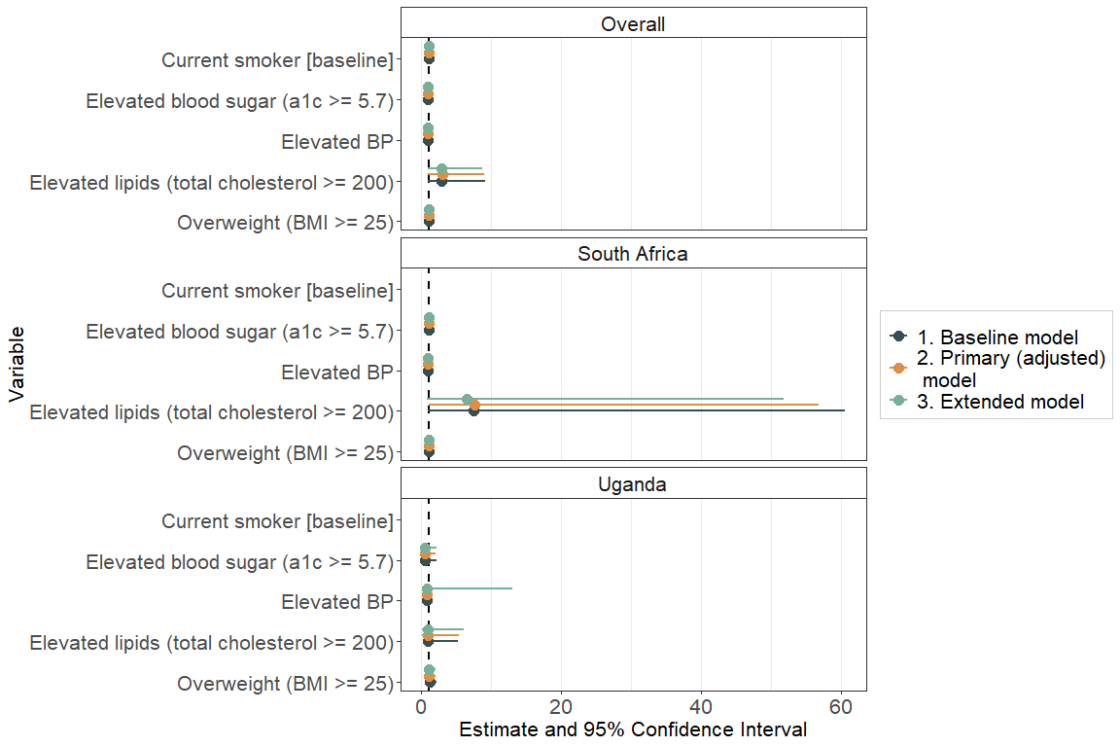

## Figure 2: Risk difference of cardiovascular risk for community-based ART compared with clinic-based care

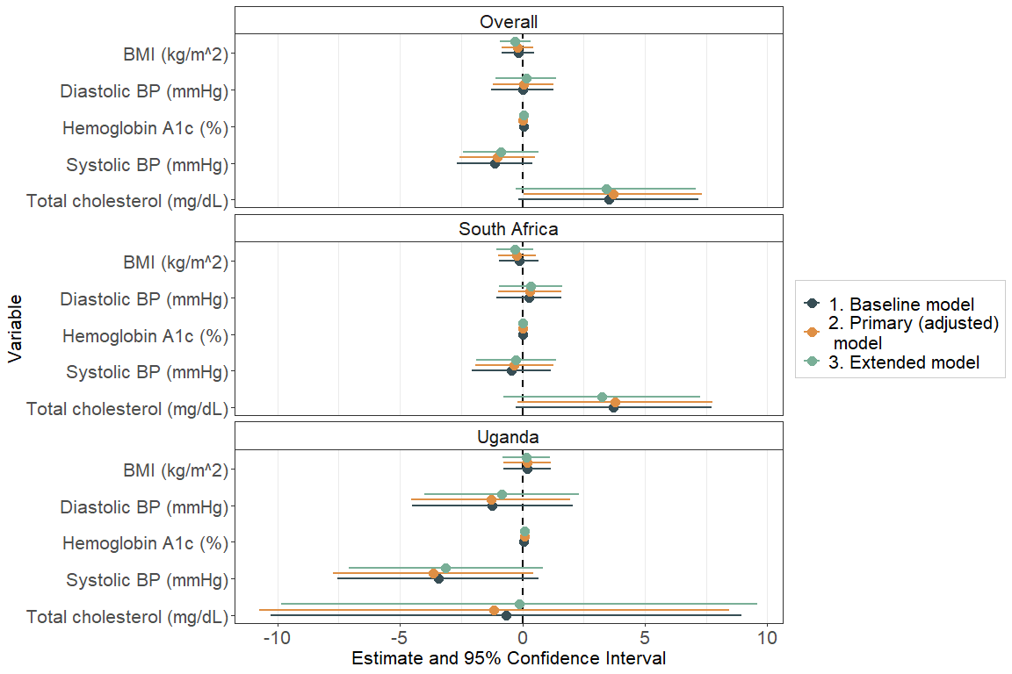

## Alternate Fig. 1: Relative risk of cardiovascular risk for community-based ART compared with clinic-based care

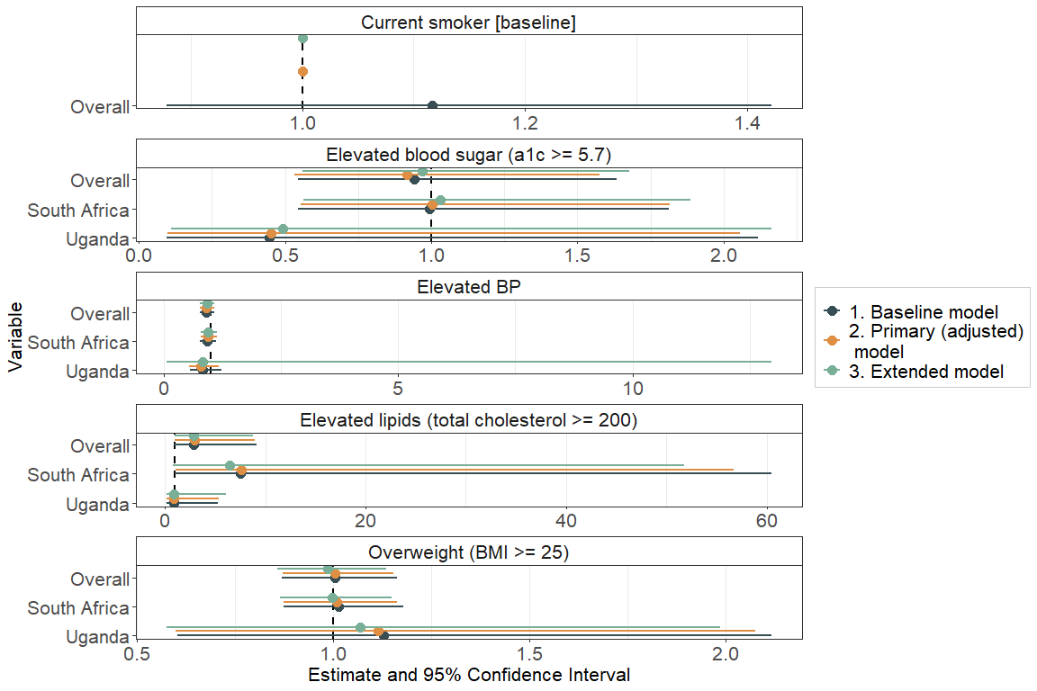

## Alternate Fig. 2: Risk difference of cardiovascular risk for community-based ART compared with clinic-based care

